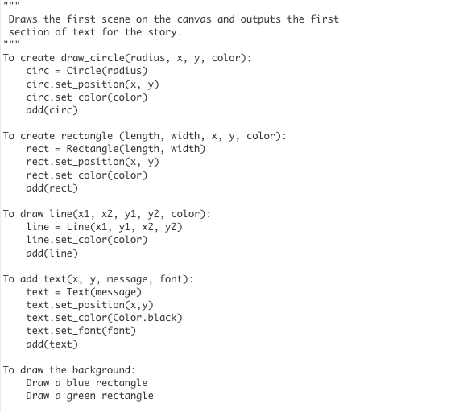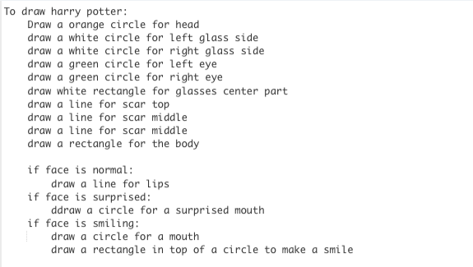

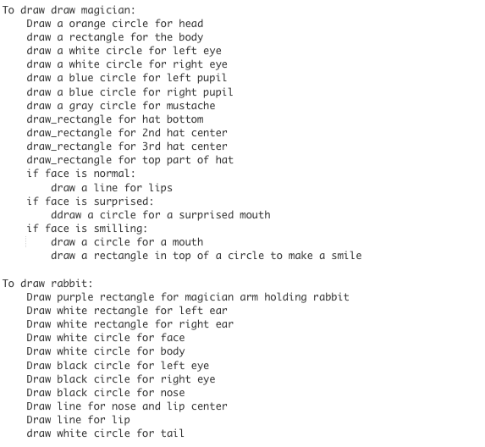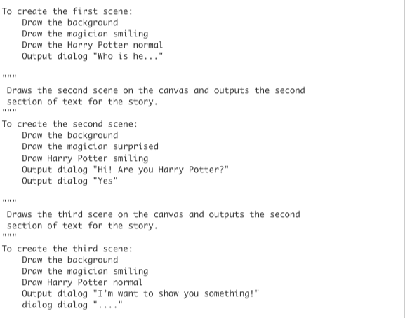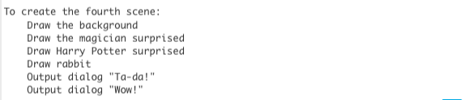

| """   Draws the first scene on the canvas and outputs the first  section of text for the story. """ To create draw_circle(radius, x, y, color):  circ = Circle(radius)  circ.set_position(x, y)  circ.set_color(color)  add(circ)  To create rectangle (length, width, x, y, color):  rect = Rectangle(length, width)  rect.set_position(x, y)  rect.set_color(color)  add(rect)   To draw line(x1, x2, y1, y2, color):  line = Line(x1, y1, x2, y2)  line.set_color(color)  add(line)  To add text(x, y, message, font):  text = Text(message)  text.set_position(x,y)  text.set_color(Color.black)  text.set_font(font)  add(text)   To draw the background:  Draw a blue rectangle   Draw a green rectangle    To draw harry potter:  Draw a orange circle for head  Draw a white circle for left glass side  Draw a white circle for right glass side  Draw a green circle for left eye  Draw a green circle for right eye  Draw white rectangle for glasses center part  Draw a line for scar top   Draw a line for scar middle   Draw a line for scar middle   Draw a rectangle for the body    if face is normal:  draw a line for lips   if face is surprised:  ddraw a circle for a surprised mouth   if face is smiling:  draw a circle for a mouth   draw a rectangle in top of a circle to make a smile   To draw draw magician:  Draw a orange circle for head  Draw a rectangle for the body  Draw a white circle for left eye  Draw a white circle for right eye  Draw a blue circle for left pupil  Draw a blue circle for right pupil  Draw a gray circle for mustache  Draw_rectangle for hat bottom   Draw_rectangle for 2nd hat center   Draw_rectangle for 3rd hat center   Draw_rectangle for top part of hat   if face is normal:  draw a line for lips   if face is surprised:  ddraw a circle for a surprised mouth   if face is smilling:  draw a circle for a mouth   draw a rectangle in top of a circle to make a smile  To draw rabbit:  Draw purple rectangle for magician arm holding rabbit  Draw white rectangle for left ear  Draw white rectangle for right ear  Draw white circle for face  Draw white circle for body  Draw black circle for left eye   Draw black circle for right eye   Draw black circle for nose  Draw line for nose and lip center  Draw line for lip   draw white circle for tail   To create the first scene:  Draw the background  Draw the magician smiling  Draw the Harry Potter normal  Output dialog "Who is he..."  """   Draws the second scene on the canvas and outputs the second  section of text for the story. """ To create the second scene:  Draw the background  Draw the magician surprised  Draw Harry Potter smiling  Output dialog "Hi! Are you Harry Potter?"  Output dialog "Yes"  """   Draws the third scene on the canvas and outputs the second  section of text for the story. """ To create the third scene:  Draw the background  Draw the magician smiling  Draw Harry Potter normal  Output dialog "I want to show you something!"  dialog dialog "...."  """   Draws the fourth scene on the canvas and outputs the second  section of text for the story. """ To create the fourth scene:  Draw the background  Draw the magician surprised  Draw Harry Potter surprised  Draw rabbit  Output dialog "Ta-da!"  Output dialog "Wow!" |
| --- |